Prerequisites and Installation Steps for E-Business Suite (11g Forms & Reports)

Step 1: Set System Date and Region
- Change the system date and time to 01-Jan-2014, 12:01 AM.
- Set the system Region to Harner PetroUr.
- Disable firewall.

Step 2: Set Environment Variable
- Open System Properties → Advanced System Settings.
- Click Environment Variables.
- Add the following system variable:
  - Variable Name: oracle_hostname
  - Variable Value: <hostname>

Step 3: Install Java JDK
- Download and install Java JDK 6u27 (Windows x64):
  - jdk-6u27-windows-x64
- Complete the installation using default settings.

Step 4: Disable User Account Control (UAC)
- Open Control Panel.
- Go to User Accounts.
- Click Change User Account Control settings.
- Set the slider to Never notify.
- Click OK.

Step 5: Restart the Machine
- Restart the system to apply the changes.

Step 6: Install Database
- Begin the Oracle Database installation as per the E-Business Suite requirements.
- Complete the installation successfully.

Step 7: Restart the Machine Again
- Restart the system after database installation.

Step 8: Install WebLogic Server
- Launch the Oracle WebLogic Server installer.
- Follow the installation wizard and complete the installation using the recommended defaults.
- Verify that WebLogic Server is installed successfully.

Step 9: Restart the Machine
- Restart the system to ensure WebLogic services are properly initialized.

Step 10: Install Oracle Forms and Reports (11g)
- Launch the Oracle Forms and Reports 11g installer.
- Select the required components (Forms, Reports, and related tools).
- Complete the installation successfully.

WebUtil Configuration Steps

Step 1: Copy Java Files
- Navigate to the java folder inside the installer folder(copy this folder from any other existing running server).
- Copy all Java files from the installer’s java folder.
- Paste them into the following directory:
C:\Oracle\Middleware\as_q\forms\java\

Step 2: Copy and Sign sign_webutil.jar
- From the WebUtil installer folder, copy the file:
sign_webutil.jar
- Paste it into the following directory:
C:\Oracle\Middleware\asinst_1\bin
- Open Command Prompt as Administrator.
- Execute the required signing command (as shown in the screenshot).
📸 Take a screenshot of the command execution and include it in the document.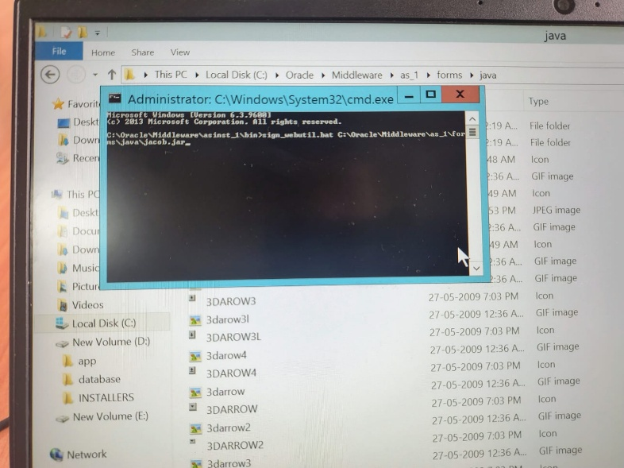

Step 3: Copy WebUtil Configuration Files
- From the WebUtil installer folder, locate the four .dll WebUtil files.
- Copy these four files to the following directory:
C:\Oracle\Middleware\as_1\forms\webutil\
- When prompted:
  - Paste the files
  - Do NOT replace or overwrite any existing files

WebUtil Configuration

1. Configure webutil.cfg
- Navigate to the WebUtil installer folder and open the backup webutil.cfg file.
- Copy the Transfer section from the installer’s webutil.cfg.
- Paste the copied Transfer section into the fresh webutil.cfg file located in the Oracle Forms directory.
- Locate the JACOB size parameter and modify it as follows:
10796 → 217600
- Save the file.
✅ webutil.cfg configuration is now complete.

2. Configure default.env
- Open the backup default.env file from the WebUtil installer folder.
- Copy the CLASSPATH entry from the backup file.
- Paste the copied CLASSPATH into the fresh default.env file.
- Add or modify the following parameter:
FORMS_MMAP=false
- From the backup default.env, copy the following paths:
  - FORMS_PATH
  - LIBRARY_PATH
  - ICON_PATH
- Paste these paths into the fresh default.env file.
- Save the file.
✅ default.env configuration is now complete.

3. Configure formsweb.cfg
- Open the backup formsweb.cfg file.
- Copy the required configuration entries.
- Paste them into the fresh formsweb.cfg file.
- Save the file.
✅ formsweb.cfg configuration is now complete.

Here is a clean, precise, and caution-focused section for rwserver.conf, written carefully since you noted this is a sensitive configuration.

Configure rwserver.conf
⚠️ Important:
This file is highly sensitive.
Do NOT add, remove, or change any spaces while editing.
Follow the backup file exactly.

Restart the Server
✅ rwserver.conf configuration and server restart completed successfully.

Final Installations and Configuration

Step 1: Install JRE
- Install JRE 7u3 (Windows x86/64):
  - Installer: jre_7u3_windows_i56.exe
- Follow the installation wizard and complete with default settings.

Step 2: Install TOAD

a) Install TOAD Client
- Launch the TOAD client installer.
- Follow the installation wizard to complete the client installation.

b) Install TOAD DBA Suite
- After installing the client, run the DBA Suite installer.
- Uncheck everything except toad

Step 3: Start TOAD
- Launch TOAD.
- If prompted for a security key:
  - Use the existing key located in the pre-existing folder from your previous installation.
  - Confirm and proceed.

Step 4: Copy Network Admin Configuration
- Navigate to the database home directory:
<DB_HOME>\network\admin
- Copy the entire admin folder.
- Navigate to the user client folder, for example:
C:\Client1
- Create a new folder named network (or another suitable name) inside the client folder.
- Paste the copied admin folder into the newly created network folder.
✅ TOAD is now installed and configured with database network access.

Java Security Configuration

Step 1: Open Java Settings
- Go to Control Panel.
- Select Programs.
- Click Java to open the Java Control Panel.
📸 Screenshot Placeholder:
[Screenshot 1: Control Panel → Programs → Java]

Step 2: Configure Security Settings
- In the Java Control Panel, go to the Advanced tab.
- Expand Security.
- Under Mixed Code (Sandboxed vs. Trusted):
  - Select Disable mixed code security verification.
📸 Screenshot Placeholder:
[Screenshot 2: Java Control Panel → Advanced → Security → Disable Mixed Code]

Step 3: Configure General Settings
- Go to the General tab.
- Under Temporary Internet Files, click Settings.
- Set Disk Space to:
220 MB
- Enable (tick) the checkbox for temporary files.
- Click OK.
📸 Screenshot Placeholder:
[Screenshot 3: Java Control Panel → General → Temporary Internet Files Settings]

Step 4: Disable JRE Auto Download
- Go to the Advanced tab.
- Expand JRE Auto-Download.
- Select Never.
📸 Screenshot Placeholder:
[Screenshot 4: Java Control Panel → Advanced → JRE Auto-Download → Never]

Step 5: Configure JNLP Settings
- In the Advanced tab, expand JNLP File/MIME Association.
- Select Always allow.
📸 Screenshot Placeholder:
[Screenshot 5: Java Control Panel → Advanced → JNLP Always Allow]

Step 6: Apply Changes
- Click Apply.
- Click OK to save the settings.
📸 Screenshot Placeholder:
[Screenshot 6: Java Control Panel → Apply and OK]

✅ Java security configuration completed successfully.

